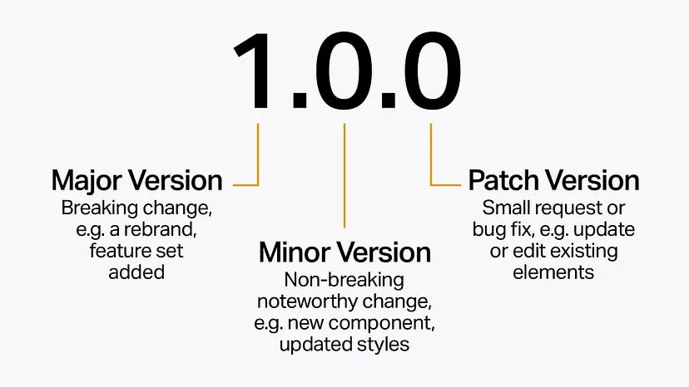

Node.js and Express.js use Semantic Versioning (SemVer) to manage software versions, consisting of three parts: MAJOR.MINOR.PATCH. ^ (caret) and latest are used in package.json to specify version ranges for dependencies, influencing how updates are installed. Major releases introduce breaking changes, minor releases add backward-compatible features, and patch releases fix bugs or security issues.

Semantic Versioning (SemVer) Explained

SemVer, used by npm and Node.js, defines a version number structure: MAJOR.MINOR.PATCH.

* **MAJOR:** Incremented when there are incompatible API changes, potentially breaking existing functionality.
* **MINOR:** Incremented when new features are added in a backward-compatible manner.
* **PATCH:** Incremented when bug fixes or minor changes are made without affecting existing functionality.

Version Specifiers in package.json

* ^ (Caret):

The caret (^) allows updates to any version that is not a breaking change. For example, ^1.2.3 would allow updates to 1.2.4, 1.3.0, but not 2.0.0. This is the default when a version is specified without a symbol.

* latest:

Specifying latest is generally discouraged for production environments because it can lead to unexpected breaking changes. It always installs the newest version, regardless of compatibility.

Releases in Node.js

* **Major Releases:**

Introduced with even numbers (e.g., Node.js 14, 16, 18), enter a "Current" release status for six months, then move to "Active LTS".

* **Active LTS (Long Term Support):**

LTS versions receive critical bug fixes and security updates for an extended period, typically 30 months.

* **Maintenance LTS:**

Older LTS versions that receive only critical bug fixes and security updates.

* **Odd-numbered releases:**

Odd-numbered releases (e.g., Node.js 11, 13) have a shorter lifespan and are not recommended for production.

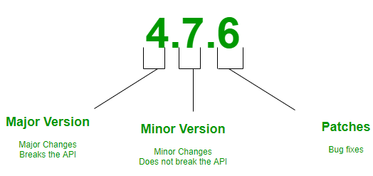

Example

If a package has a version 1.2.3 and uses the ^ specifier, it might update to 1.2.4 or 1.3.0 but not 2.0.0. If latest is specified, it would always update to the newest version, which could be 2.0.0 if a breaking change was introduced.

By understanding SemVer and how version specifiers work, developers can manage dependencies effectively and minimize the risk of breaking changes in their Node.js and Express.js projects.

To fully understand how versioning works in **Node.js** and its ecosystem (primarily **npm**, the Node.js package manager), we need to dive deeper into **Semantic Versioning (SemVer)** and its implications in practice.

**1. Semantic Versioning Overview**

Semantic Versioning (SemVer) uses a MAJOR.MINOR.PATCH structure:

**MAJOR (X.y.z)**

* Changes here indicate **breaking changes**.
* These are updates that are **not backward-compatible** and may require users to modify their code to use the new version.
* Example Scenarios:
  + Removing or renaming a public API method.
  + Changing how a function behaves (e.g., changing input/output).
  + Refactoring the project in a way that breaks its integration.

**MINOR (x.Y.z)**

* Changes here add **new features or enhancements** that are backward-compatible.
* These do not break existing functionality.
* Example Scenarios:
  + Adding a new optional argument to a function.
  + Providing additional utilities or methods that coexist with existing ones.
  + Performance optimizations that don’t alter the API.

**PATCH (x.y.Z)**

* Changes here are **bug fixes** or minor corrections.
* These address defects without changing the behavior or introducing new features.
* Example Scenarios:
  + Fixing a typo in the code that doesn’t affect the functionality.
  + Correcting edge cases for a function without altering its core behavior.

**Pre-release Versions**

Pre-releases use a suffix appended to the version, such as -alpha, -beta, or -rc (release candidate), followed by a number. These are primarily for testing and development:

* 1.0.0-alpha.1: An unstable alpha version.
* 1.0.0-beta.2: A more stable beta release.
* 1.0.0-rc.1: A release candidate close to final.

Pre-releases are considered lower precedence than the corresponding full release. For example:

* 1.0.0-alpha.1 < 1.0.0-beta.1 < 1.0.0.

**Build Metadata**

A + symbol can specify build metadata, which is ignored in version precedence but can be useful for tracking. Example:

* 1.0.0+20231130.

**2. Versioning in Node.js Core**

Node.js itself follows SemVer principles:

* **LTS (Long-Term Support):**
  + Node.js has LTS versions, typically maintained for 30 months.
  + LTS versions focus on stability and receive **patches and minor updates only**.
  + Example: 18.x.x might remain stable while receiving security patches.
* **Current Releases:**
  + These are feature-rich but shorter-lived.
  + Example: 20.x.x might include experimental APIs that are subject to breaking changes.
* **Even/Odd Versioning:**
  + Even-numbered releases (16, 18, 20) are LTS versions.
  + Odd-numbered releases (17, 19, 21) are experimental and not recommended for production.

**3. Versioning in npm and Dependencies**

**3.1 Version Range Specifiers**

npm allows flexible dependency specifications. These range specifiers control which updates your project will accept when running npm install.

1. **Caret (^)**:
   * The default behavior in npm.
   * Accepts updates to the **current MAJOR version**.
   * Example:
     + ^1.2.3 allows 1.x.x (e.g., 1.3.0, 1.4.5), but not 2.0.0.
     + ^0.2.3 allows 0.2.x, but not 0.3.0 or 1.0.0 (special rule for 0.x).
2. **Tilde (~)**:
   * Allows updates to the **current MINOR version**.
   * Example:
     + ~1.2.3 allows 1.2.x (e.g., 1.2.4, 1.2.9), but not 1.3.0.
3. **Exact Version**:
   * Locks the dependency to a specific version.
   * Example: 1.2.3 installs exactly 1.2.3.
4. **Wildcard (*)**:
   * Accepts any version.
   * Example: * matches the latest version available.
5. **Range Combinations**:
   * Use logical operators for custom ranges.
   * Example:
     + >=1.2.0 <2.0.0 accepts anything from 1.2.0 to 1.9.x.

**3.2 Package.json and Version Constraints**

In the package.json file, dependencies are listed like this:

{

"dependencies": {

"express": "^4.17.1",

"lodash": "~4.17.20",

"axios": "0.21.1"

}

}

Each dependency uses the versioning rules described above. Running npm update respects these constraints.

**3.3 Lock Files**

* **package-lock.json** or **yarn.lock** ensures that exact versions are installed across environments, even if package.json specifies version ranges.
* These files:
  + Provide deterministic builds.
  + Record the exact dependency tree.

**4. Common Challenges in Versioning**

1. **Breaking Changes in Dependencies:**
   * A dependency releasing a breaking change (e.g., bumping the MAJOR version) might break your application if carelessly updated.
2. **Peer Dependencies:**
   * These are dependencies that your project relies on indirectly.
   * Example:

{

"peerDependencies": {

"react": ">=16.8.0"

}

}

* Developers are expected to ensure compatibility manually.

1. **Transitive Dependencies:**
   * These are dependencies of your dependencies.
   * Managing them can become complex, especially if they introduce conflicting versions.

**5. Real-World Best Practices**

1. **Pin Dependencies for Production:**
   * Use exact versions or lock files in production to ensure consistency.
2. **Use npm outdated:**
   * Regularly check for outdated packages using:

npm outdated

* This displays the current, wanted, and latest versions.

1. **Test Upgrades Thoroughly:**
   * Always test major and minor version updates in staging environments.
2. **Update Frequently:**
   * Don’t let dependencies become outdated; this can increase the difficulty of upgrading later.
3. **Understand Deprecation Notices:**
   * Check changelogs and migration guides for breaking changes.

**6. Node.js Release Schedule and Support**

Node.js follows a predictable release schedule:

* Every **April and October**, a new MAJOR version is released.
* LTS versions transition from “Active LTS” to “Maintenance LTS” before becoming unsupported.

Example:

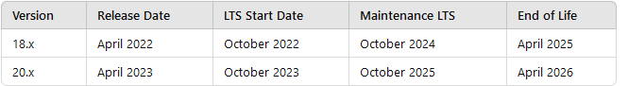

**Conclusion**

Versioning in Node.js and npm is governed by SemVer, ensuring clarity about the impact of updates. By understanding and managing version ranges, lock files, and release cycles, developers can maintain stability, predictability, and security in their projects. Proper versioning practices lead to smoother workflows and fewer surprises during upgrades.